[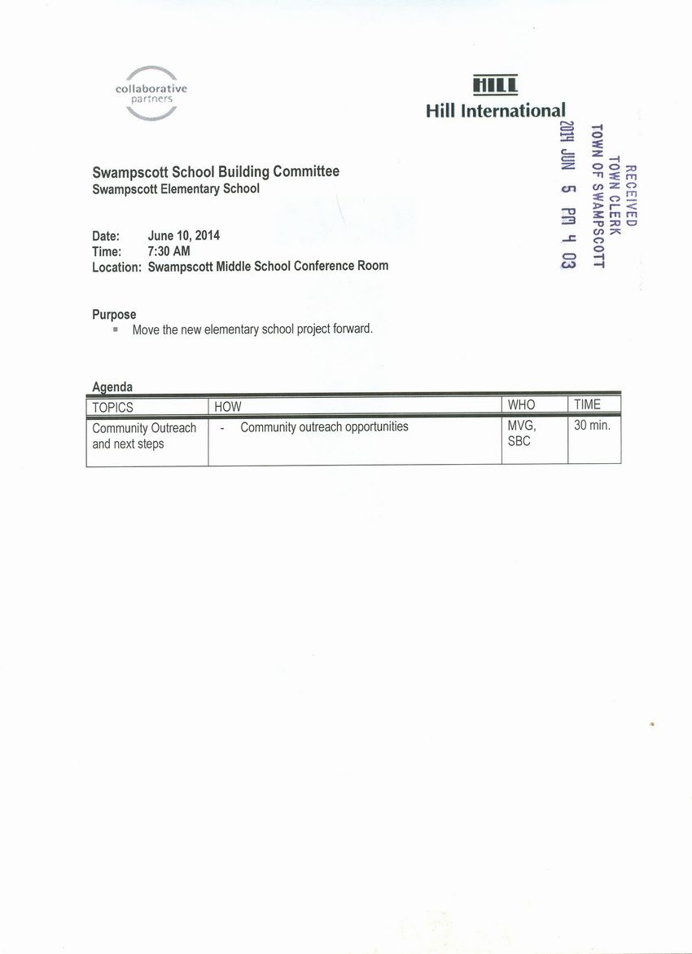](http://www.town.swampscott.ma.us/Public_Documents/SwampscottMA_Calendar/S048C8C12-048C8C56.0/School%20Building%20June%2010th%20notice%20001.jpg)